
NOTE :.

NOTE :.

|x + 2| = 9
- What is the solution to the given equation?
  - 7
  - 11
  - -7
  - 4

|x - 4| = 19
- What are all the solution to the given equation?
  - -15 and 23
  - 15 only
  - 23 only
  - 15 and -23

2|x-9| = 20
- What is the sum of the solution to the given equation?
  - 18
  - 20
  - 19
  - -1
|x-1| = 8
- If x is a solution to the given equation, what is a possible value of x - 1?
- -6
- 6
- 7
- -8

|x + 2| = |x - 8|
- What is the solution to the given equation?
  - -3
  - 3
  - -6
  - 6

|x + 3| = 0
- Exactly how many solutions does the given equation have?
- Three
- One
- Two
- Zero

4x - 2y > 8
- Which of the following ordered pairs (x, y) are in the solution set for the inequality above?
- (-1,-10)
II. (2,0)
III. (1,-2)
- III only
- I only
- II only
- I and II only
y > 4x
y < -x
- When graphed in the xy-plane, what point (x, y) is a solution to the given system of inequalities?
 A. (3,-3)
B. (1,1)
C. (-2,-2)
D. (-4,4)

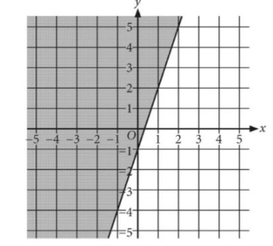
- Which shaded region shown represents the solutions to which inequality?
- y ≤ - 3x + 1
- $y ≥-3x + 1$
- y ≥ 3x-1
- y ≤ 3x-1

- $y =-2x+3$ and $y = x - 3$ . Point P (not shown) has (2, -4)
and lies in the shaded region. Which of the following is (are) true about point P?
I. The coordinates of P satisfy $y < -2x+3$
II. The coordinates of P satisfy $y > x-3$
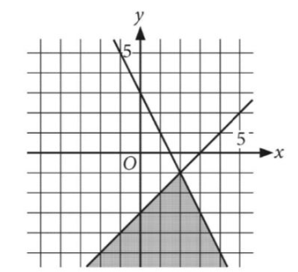
- Neither I nor II
- I only
- I and II
- II

- At the beginning of a laboratory experiment, Miguel had 10 milliliters of a solution in a flask. The first step of the experiment consisted of Miguel pouring x milliliters of the solution into a beaker and y milliliters of the solution into a different beaker. There remained at least 4 milliliters of the solution in the flask after the first step. Which of the following inequalities can be used to correctly represent this situation?
- $4-x+y ≥5$
- 10 – x +y $≥$4
- 10 – x - y $≥$4
- 4 – x -y $≥$5
- Howard needs to move a large number of boxes from one floor to another in an office building by using an elevator. The elevator has a weight limit of 650 pounds. Howard weighs 160 pounds and each box weighs 35 pounds. Which of the following inequalities describes the limit on the number of boxes, b, that Howard can ride with in the elevator in one trip?
A. $160b+35 ≤650$
B. $35b+160 ≤650$
C. $35\left(b+160\right)≤650$
D. $35b-160 ≤650$
- Ms. Anderson currently has 550 contracts on an online professional networking site. Her goal is to have at least 1,000 contracts. If she wants to meet this goal in 25 weeks, what is the minimum number of contracts per week, on average, she should add?
- 22
- 18
- 21
- 1
- Sanjay works as a teacher's assistant for 20 per hour and tutors privately for 25 per hour. Last week, he made at least 100 working x hours as a teacher's assistant and y hours as a private tutor. Which of the following inequalities models this situation?
- $5x + 4y ≥20$
- $5x + 4y ≥25$
- $4x + 5y ≥25$
- $4x + 5y ≥20$

- A company offers its salespeople two different weekly compensation plans. Salespeople on Plan X earn 1,000 plus a 10% commission their sales each week. Salespeople on Plan Y earn 500 plus a 20% commission on their sales each week. Which inequality models the amount in sales each week, d dollars, for which salespeople on Plan X earn more than salespeople of Plan Y?
- d < 5000
- d < 1500
- d > 5000
- d > 1500
- In ancient Egypt, from 2810 BC to 2800 BC, the course of the Nile riverbed moved eastward at least 2 meters per year but no more than 3 meters per year. Which of the following inequalities represents all possible values for the total distance, d, in meters, the Nile riverbed moved eastward for 4 consecutive years during this time period?
- 2 $\text{≤}$d $\text{≤ }$3
- $\text{0}\text{ ≤} \text{d} \text{ ≤} \text{2 }$
- 8 $\text{≤}$d $\text{≤}$12
- 4 $\text{≤}$d $\text{≤}$8

